**LAB NO 07**

**CONVERSION OF C PROGRAMS TO MIPS ASSEMBLY LANGUAGE**



**Fall 2024**

**CSE-304L Computer Organization and Architecture Lab**

Submitted by:

Name : **Hassan Zaib Jadoon**

Reg no**. : 22PWCSE2144**

ClassSection **: A**

Signature: ____________

Submitted to:

**Dr. Amaad Khalil**

**Department of Computer Systems Engineering**

**University of Engineering and Technology, Peshawar**

**Lab: 7 FLOATING POINT PROGRAMMING**

**Objective:**

To do floating point programming because most of the computations also involve some floating-point arithmetic. For this purpose MIPS supports various floating point instructions along with having 32 special floating point registers f0-f31.

**Task 1:**

Write a MIPS program to perform the floating point addition, subtraction, multiplication and division.

**Code:**

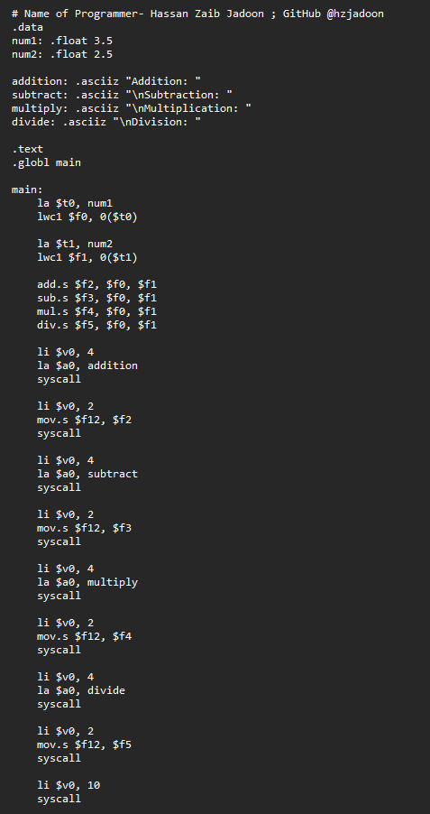

**Output:**

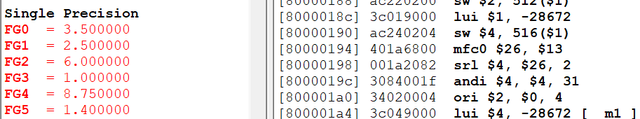

**Task 2:**

Program to display all prime numbers between Two interval entered by user.

**Code:**

**Output:**

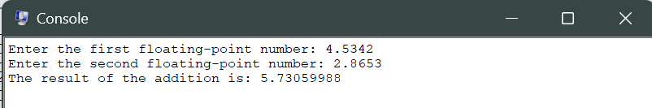

**Task 3**

Program to find the factorial of a number entered by the user

**Code:**

**Output:**

**Task 4**

Write down a MIPS program that utilizes the max function. Your program should contain an array of 10 floating point numbers whose address is passed in $a0 and the max float number is returned in $f12. You declare a floating point number in memory using the **.float** directive e.g.: .float 32.501. The program should print max of the ten integers(using SYSCALL with v0 = 2 and number in f12).

**Output:**

